
CS 1010 Project3 – Give me a break!
30 Points
Due: 10/24 @ 11:30

Propose:
In this project, you will write a complete Python program. This project will help you to practice functions in a Python program.

Instructions:
- Follow these steps.
  - Create the ###lastnameproj3.py and ###lastnameproj3.docx onto your desktop (use your class code for ### and your last name, copy the lab4 file with all that good code)
  - Launch Pyscripter and open the .py file from within Pyscripter.

- Change the banner documentation to reflect your new task and add your class code and name to the comments at the top as following:
#Name : ###YourLastNames

- This Python program will complete the following program description
The Holiday Travel Agency is putting together some travel packages for vacations, and they would like a program that will help them calculate the cost of a customer’s trip. They have 4 destinations which they will offer at different prices:
Make these global constants (declared above your functions)
Destination Rate per day(hotel) Air fare
Florida $ 70.00 $ 175.98
Texas $ 60.00 $ 225.98
Cancun $100.00 $ 474.98
Bahamas $ 95.00 $ 355.98

To encourage people to stay longer, they have the following long stay discount. If you stay for more than 7 days there will be a price reduction based on their destination.

- Florida or Texas: one day free
- Cancun or Bahamas: 50% off the airfare

There is also an early discount based on how far ahead the reservation is made. This discount is to be applied to the hotel cost. Initialize the discount rates locally with the function.

- Reservation 1 - 4 weeks in advance no discount
- Reservation 5 - 6 weeks in advance 5% discount off the hotel cost
- Reservation 7-9 weeks in advance 8% discount off the hotel cost
- Reservation 10 or more weeks in advance 10% discount off the hotel cost

Suggested main function algorithm and function names:
(you will need to determine the arguments and return values.
  - Input all data
  - Call getHotelCost
  - Call getAirFareCost
  - Call getLongDisc
  - Call getEarlyDisc
  - Calculate the final bill
  - Call printVacationPackage

Run your code with the following input to yield the indicated output. Although you are submitting four samples, you must test for all possible scenarios.
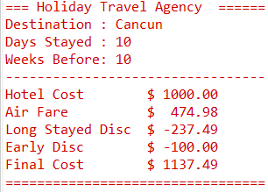
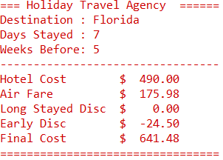

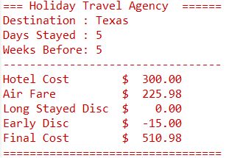
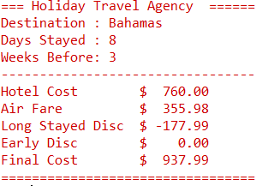

Open the ###lastnameproj3.docx (with your class code) file and copy your output into the file using the snipping tool. You will have four sets of output. (see above)

Grade Sheet

CS1010 Project 3: Give Me A Break

Name ______________________________________

Project turned in and Coding standards:

(4) Python file and output files named correctly and turned in correctly (your own class code and last name)

(5) In-line comments complete (function comments above each function including the main)
Example function header comments:
# Function: MileCost will calculate the cost for any excessive miles.

- The above items are not a part of the 30 points but will be deducted if not implemented

Coding:

(5) Global/Local Constants (Hotel Rate and Air Fares - global, Discount Rates- local)

(5) Main function contains input statements, function calls and final bill calculation (above all other functions)

(4) getHotelCost

(4) getAirFareCost

(4) getLongDisc

(4) getEarlyDisc

(4) printVacationPackage

(30 maximum) Total Points

